# Section 1: Health Hazards, Exposure, and Impact

## 1.1 Health and heat

### Indicator 1.1.1: exposure of vulnerable populations to heatwaves

Indicator Authors

Dr Federico Tartarini, Prof Ollie Jay

Methods

Heatwave Indicator Definition and Methodology

The heatwave indicator defines a heatwave as a period of two or more consecutive days in which both the minimum and maximum temperatures exceed the 95th percentile of the local climatology, based on the 1986–2005 reference period. The indicator is designed to capture both direct heat stress from high maximum temperatures and the health risks associated with insufficient nighttime cooling due to elevated minimum temperatures.

To determine heatwaves, the 95th percentile of daily minimum and maximum temperatures was computed using the European Centre for Medium-Range Weather Forecasts (ECMWF) ERA5 dataset, gridded at a 0.25° × 0.25° global resolution for the 1986–2005 baseline period. Based on this definition, the number of heatwave events and the total number of heatwave days per year were calculated for each year from 1980 to 2023.

Vulnerable Populations and Exposure Calculation

Vulnerable populations are defined as individuals over 65 years of age, 75 years of age, and infants under one year old, as these three groups are particularly susceptible to heat-related health impacts.

Exposure is calculated using the person-days metric, which quantifies heatwave exposure by multiplying the number of heatwave days by the total vulnerable population. This approach ensures the indicator reflects changes in both heatwave frequency and duration, as well as demographic shifts that may increase the number of at-risk individuals.

Global gridded demographic data from the WorldPop project, available at a 1 km × 1 km resolution for the period 2000–2020, was used to identify vulnerable populations, based on the “top-down unconstrained approach”. For infants under one year old, separate datasets for males and females were aggregated at each grid point. For the older individuals, age groups were merged by summing the respective datasets. For individuals over 75 years of age we included the datasets 75–80, and 80+, while for individuals over 65 years of age we also included the following datasets 65–70, 70–75. These aggregated datasets were then downscaled to match the ERA5 grid resolution (0.25° × 0.25°) by identifying the nearest neighbour for each ERA5 grid point and summing corresponding values.

For historical demographic data prior to 2000, the Lancet Countdown 2023 dataset was used. This dataset was generated from the ISIMIP Histsoc dataset and resampled to a 0.25° × 0.25° resolution using a 2D linear interpolation method that incorporates population densities and NASA GPWv4 land area data. This dataset only contains data for individuals over 65 years of age. Hence, we were only able to calculate the exposure of individuals above 75 years of age from the year 2000.

Post-2020 population projections were estimated using linear interpolation at each grid point. Given the discontinuity in population datasets across time periods (pre and post 2000), direct comparisons of population changes were avoided. Instead, the analysis focuses on changes in exposure to heatwaves, mitigating inconsistencies in demographic data across different sources.

The WorldPop methodology combines census data, surveys, and remote sensing, though data quality and timelines vary by region. In areas with limited data or political instability, the approach relies more heavily on modelling.

Code and resources to reproduce the results

The results were generated using Python, a copy of the code is available in this public repository https://github.com/FedericoTartarini/paper-lancet-countdown-global. Users who want to reproduce the results will first need to download the datasets listed below. Then they can use the code to reproduce the results, please refer to the README file in the public repository which contains detailed instructions on how to run the Python code.

Data

* **Climate Data**: ECMWF ERA5 reanalysis dataset
* **Demographic Data (1980–2000)**: Hybrid gridded demographic dataset from the Lancet Countdown 2023 (0.25° resolution)
* **Demographic Data (2000–2020):** WorldPop Age and Sex Structure Unconstrained Global Mosaic

Caveats

To ensure consistency over time, data from multiple sources were integrated to capture both spatial and temporal demographic trends. However, validation of this integrated dataset is limited. In regions with sparse demographic data or shifting political boundaries, inconsistencies may arise in the spatial distribution of populations. For example, the division of Sudan is reflected in the dataset as missing or incomplete information for infant populations, illustrating the challenges of maintaining demographic continuity in dynamically changing regions.

WorldPop’s "top-down unconstrained" approach was used for population mapping. This method estimates population distribution without restricting allocation to residential areas, unlike the "constrained" approach, which relies on satellite imagery to identify inhabited locations. While this method ensures continuous coverage across all land areas, it may overestimate populations in low-density regions and underestimate them in high-density areas.

Future form of the indicator

Discuss with Ollie

Additional analysis

Figure 1 illustrates the change in the number of heatwave days in 2024 compared to the baseline period, highlighting intense events across the Americas, Africa, Central and Eastern Europe, the Middle East, East and Southeast Asia, and Central Asia.

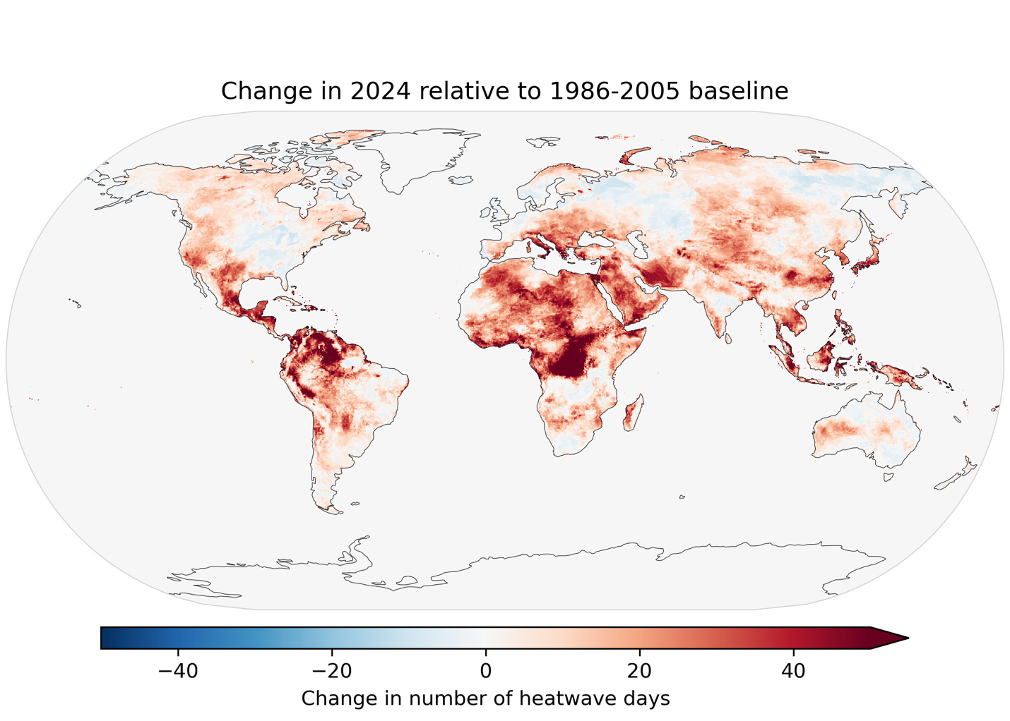

Figure 1. Map depicting the change in the number of heatwave days over land in 2023 compared to the 1986–2005 baseline.

The total number of heatwave days experienced annually by individuals in vulnerable age groups rose by more than 44% for all groups. Older adults (65+) endured a record 17.7 billion person-days of heatwaves (49% increase), people aged 75 year experienced 6.4 billion person-days, while infants under one year experienced 2.9 billion person-days, as illustrated in Figure 2.



Figure 2. Total number of heatwaves days experienced per year by older adults and infants.

Figure 3 shows that on average across the world heatwave exposure is the highest among individuals over 75 (21.1 heatwave days per person), followed by those aged 65+ (20.8 heatwave days per person). Infants experienced on average 20.5 heatwaves days per person.



Figure 3. Average number of heatwave days experienced by individuals over 65 and infants under one year old.

When analyzed by country, as shown in Figure 3 and Figure 4, China and India are the countries with the highest number of affected individuals in both age categories, primarily due to their large populations. In 2024, a significant number of people over 65 were also impacted in Japan, the United States of America, and Italy, while heatwave exposure among infants was particularly high in Indonesia, Nigeria, and the Democratic Republic of the Congo.



Figure 4. Total heatwave person-days experienced by infants under one year old, presented by year and by the most affected countries.



Figure 5. Total heatwave person-days experienced by individuals over 65, presented by year and by the most affected countries.

Before 2024, countries classified as ‘Low’ HDI, on average, exhibited lower heatwave exposure for both age groups, as shown in Figure 6. However, these countries experienced the fastest growth in 2024 and both groups experienced at more than 20 heatwaves days per year on average.



Figure 6. Average number of heatwave days experienced aggregated by HDI level.

Figure 7 presents data aggregated by WHO regions. The Wester Pacific region was the most affected for the infants (under 1) and the over-65 population.



Figure 7. Average number of heatwave days experienced aggregated by WHO region.

Additional analysis

While climate change drives the increase in heatwave days, population growth also contributes to the rising number of heatwave person-days. This section compares the periods 1986–2005 and 2006–2024 to estimate how many heatwave days vulnerable populations would have experienced if climate change had not occurred, considering only demographic shifts.

For each geographic coordinate, the average annual heatwave days affecting both elderly and infant populations were calculated for 2006–2024. The same calculation was repeated while holding heatwave incidence constant to the 1986–2005 levels, isolating the impact of climate change. Comparing these scenarios reveals how many heatwave days vulnerable populations would have been exposed to purely due to demographic changes.

Under a constant heatwave incidence at baseline levels, vulnerable populations would have experienced an average of 5.4 heatwave days per person per year in 2006–2024—50% fewer than observed. Infants faced an average increase of 4.6 heatwave days per year, while individuals over 65, a rapidly growing group, experienced an additional 5.3 heatwave days annually. For infants a slight decrease in per-person heatwave exposure (from 4.8 to 4.6) would have been observed if heatwave incidence remained at 1986–2005 levels, reflecting shifts in the geographic distribution of vulnerable populations. No change, would have been observed for adults ages 65 years or over.